# Diabetes Classification Results using SVC

## Classification Report:

precision recall f1-score support  
  
 0 0.79 0.72 0.75 146  
 1 0.75 0.82 0.79 154  
  
 accuracy 0.77 300  
 macro avg 0.77 0.77 0.77 300  
weighted avg 0.77 0.77 0.77 300

## ROC AUC Score:

ROC AUC Score (SVC): 0.8436666073652376

## ROC Curve:

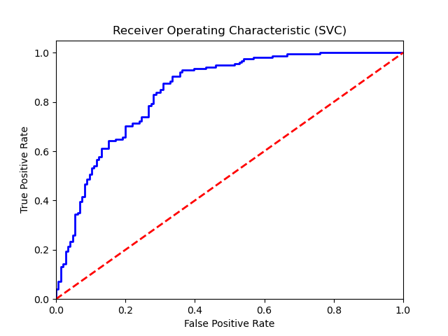

## Confusion Matrix:

True Negatives: 105

False Positives: 41

False Negatives: 28

True Positives: 126

## Confusion Matrix Plot:

